# CD LAB 2

NAME: Janvii RV

SRN: PES2UG22CS232

DATE: 17/02/2025

To run the codes, please use the run.sh file.

./run.sh

Input:

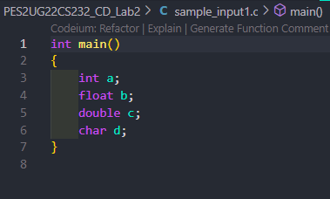

Output Screenshot:

